JavaScript Algorithms and Data Structures Projects:

Palindrome Checker
function palindrome(str){
var check= str.replace(/[\W_]/gi,'').toLowerCase();
console.log(check)
var strReverse = check.split('').reverse().join('');
console.log(strReverse)
if (strReverse === check){
return true;
}else{
return false;
}
}

palindrome("eye");
console.log(palindrome("_eye"))

Roman Numeral Converter
Convert the given number into a roman numeral. All roman numerals answers should be provided in upper-case. Try to pair program. Write your own code.
function convertToRoman(num) {
const romanTable = {
M: 1000,
CM: 900,
D: 500,
CD: 400,
C: 100,
XC: 90,
L: 50,
XL: 40,
X: 10,
IX: 9,
V: 5,
IV: 4,
I: 1,
};
let accumulator = '';
for (const key in romanTable){
const numberValue = romanTable[key];

while (numberValue <= num){
num -= numberValue;
accumulator += key;
}
}
return accumulator;
}

console.log(convertToRoman(36));

Caesars Cipher
One of the simplest and most widely known ciphers is a Caesar cipher, also known as a shift cipher. In a shift cipher the meanings of the letters are shifted by some set amount. A common modern use is the ROT13 cipher, where the values of the letters are shifted by 13 places. Thus 'A' ↔ 'N', 'B' ↔ 'O' and so on. Write a function which takes a ROT13 encoded string as input and returns a decoded string. All letters will be uppercase. Do not transform any non-alphabetic character (i.e. spaces, punctuation), but do pass them on. Try to pair program. Write your own code.
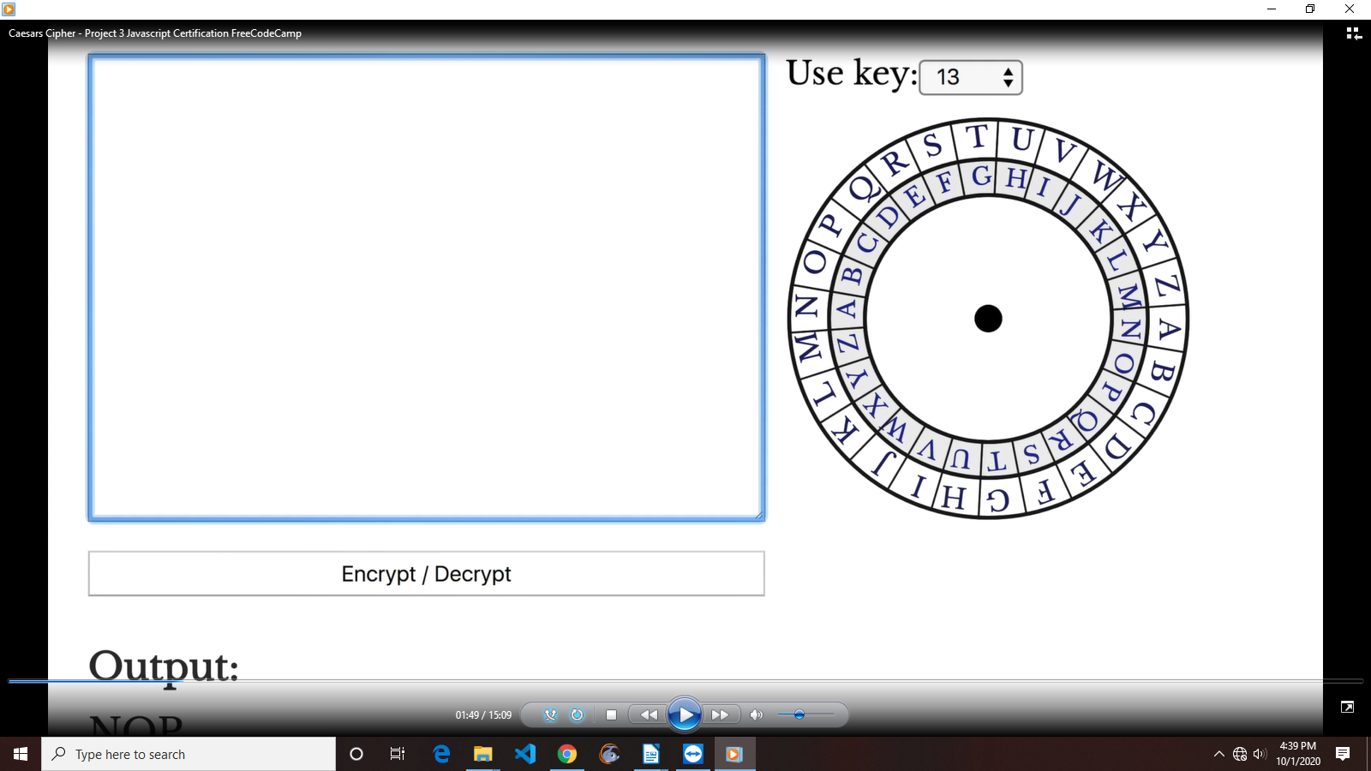
const alphabet = [
"A",
"B",
"C",
"D",
"E",
"F",
"G",
"H",
"I",
"J",
"K",
"L",
"M",
"N",
"O",
"P",
"Q",
"R",
"S",
"T",
"U",
"V",
"W",
"X",
"Y",
"Z"];

function rot13(str) { // LBH QVQ VG!
let accumulator = "";

for (let i = 0; i < str.length; i++){
const char = str[i];
const isALetter = alphabet.includes(char);

if (isALetter === false){
accumulator += char;
} else {
const charIndex =
alphabet.findIndex((c) => c === char);

accumulator += alphabet[charIndex + 13] ||
alphabet[charIndex - 13];
}
}
return accumulator;
}

// Change the inputs below to test
console.log(rot13("SERR PBQR PNZC"));

Telephone Number Validator
function telephoneCheck(str) {
const numValidator = /^1? ?(( ?\d{3}[- ]*)|(\( ?\d{3}[- ]*\) *))\d{3}[- ]?\d{4}$/;
return numValidator.test(str);
}

console.log(telephoneCheck("555-555-5555"));

Cash Register
Design a cash register drawer function checkCashRegister() that accepts purchase price as the first argument (price), payment as the second argument (cash), and cash-in-drawer (cid) as the third argument. cid is a 2D array listing available currency. The checkCashRegister() function should always return an object with a status key and a change key. Return {status: "INSUFFICIENT_FUNDS", change: []} if cash-in-drawer is less than the change due, or if you cannot return the exact change. Return {status: "CLOSED", change: [...]} with cash-in-drawer as the value for the key change if it is equal to the change due. Otherwise, return {status: "OPEN", change: [...]}, with the change due in coins and bills, sorted in highest to lowest order, as the value of the change key. Try to pair program. Write your own code.
Currency Unit | Amount
Penny | $0.01 (PENNY)
Nickel | $0.05 (NICKEL)
Dime | $0.1 (DIME)
Quarter | $0.25 (QUARTER)
Dollar | $1 (DOLLAR)
Five Dollars | $5 (FIVE)
Ten Dollars | $10 (TEN)
Twenty Dollars | $20 (TWENTY)
One-hundred Dollars | $100 (ONE HUNDRED)

// Create an array of objects which hold the denominations and their values
var denom = [
{ name: "ONE HUNDRED", val: 100.0 },
{ name: "TWENTY", val: 20.0 },
{ name: "TEN", val: 10.0 },
{ name: "FIVE", val: 5.0 },
{ name: "ONE", val: 1.0 },
{ name: "QUARTER", val: 0.25 },
{ name: "DIME", val: 0.1 },
{ name: "NICKEL", val: 0.05 },
{ name: "PENNY", val: 0.01 }
];

// Transform CID array into drawer object
// Here is your change, ma'am.
function checkCashRegister(price, cash, cid) {
var output = { status: null, change: [] };

var change = cash - price;
var register = cid.reduce(
function(acc, curr) {
acc.total += curr[1];
acc[curr[0]] = curr[1];
return acc;
},
{ total: 0 }
);
// Handle exact change
if (register.total === change) {
output.status = "CLOSED";
output.change = cid;
return output;
}
// Handle obvious insufficient funds
if (register.total < change) {
output.status = "INSUFFICIENT_FUNDS";
return output;
}
// Loop through the denomination array
var change_arr = denom.reduce(function(acc, curr) {
var value = 0;
// While there is still money of this type in the drawer
// And while the denomination is larger than the change remaining
while (register[curr.name] > 0 && change >= curr.val) {
change -= curr.val;
register[curr.name] -= curr.val;
value += curr.val;
// Round change to the nearest hundreth deals with precision errors
change = Math.round(change * 100) / 100;
}
// Add this denomination to the output only if any was used.
if (value > 0) {
acc.push([curr.name, value]);
}
return acc; // Return the current change_arr
}, []); // Initial value of empty array for reduce
// If there are no elements in change_arr or we have leftover change, return
// the string "Insufficient Funds"
if (change_arr.length < 1 || change > 0) {
output.status = "INSUFFICIENT_FUNDS";
return output;
}
// Here is your change, ma'am.
output.status = "OPEN";
output.change = change_arr;
return output;
}

checkCashRegister(19.5, 20, [["PENNY", 1.01], ["NICKEL", 2.05], ["DIME", 3.1], ["QUARTER", 4.25], ["ONE", 90], ["FIVE", 55], ["TEN", 20], ["TWENTY", 60], ["ONE HUNDRED", 100]]);

